March Newsletter.

In this edition
Welcome to the March edition of the Midlands Greener NHS Newsletter. Please do
share this across your network.
In this issue we include news on.....
- More funding to electrify the fleet
- Gold for UHCW ED!
- A Climate Clinic for nurses, midwives and AHPs
- The NHS Excellence Awards
- Plus much, much more...
As ever, please do send us in your stories, case studies and events so we can share them with colleagues across the Midlands.
Published by the Greener NHS team at NHS England - Midlands.
Links to the Future NHS website may require you to register or login to view.

A note from the team
This is an incredibly tough time for many parts of the NHS. We are proud to work with you all to drive this important agenda forward, and we will do our best to continue to support you.
The region is about to launch into a consultation period, which may change the activities that we are able to undertake. We'll do our best to keep you updated.
Kim Croasdale is also sad to announce her imminent departure from the Midlands Greener NHS team, as she takes voluntary redundancy. Her last working day is 11th March.

Spotlight
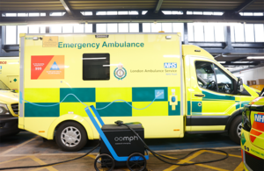
Health service to save millions with boost to electrify NHS fleet
On 27th January, Government announced a £4 million boost to roll out hundreds of new electric vehicle charging sockets, thanks to an extension to the Department for Transport's NHS Chargepoint Accelerator Scheme.
Applications are not open yet, but NHS England will be inviting expressions of interest from trusts in April.
The announcement includes details of the £10 million already awarded from DHSC for electrical vehicle charges.
Read the announcement.

Clinical practice

Gold for UHCW ED!
Enormous congratulations to UHCW ED, who have been awarded the Gold GreenED accreditation by the RCEM!
Read more here.

Nursing & Midwifery and AHP Climate Clinic
The Nursing & Midwifery Challenge will be running again in 2026, but due to the enormous restructures and challenges faced by the system at the moment, it's been decided to delay it until the Autumn.
However, the Chiefs of Nursing & Midwifery and AHPs in the Midlands feel that it's important to support staff in a welcome and interactive space to explore how we can create a greener NHS together.
Join this session, following the spotlight conversation between Suzanne Rastrick, Chief AHP Officer, and Chris Gormley, Chief Sustainability Officer on 22nd April 1pm-1:30pm.
Join the spotlight conversation here.
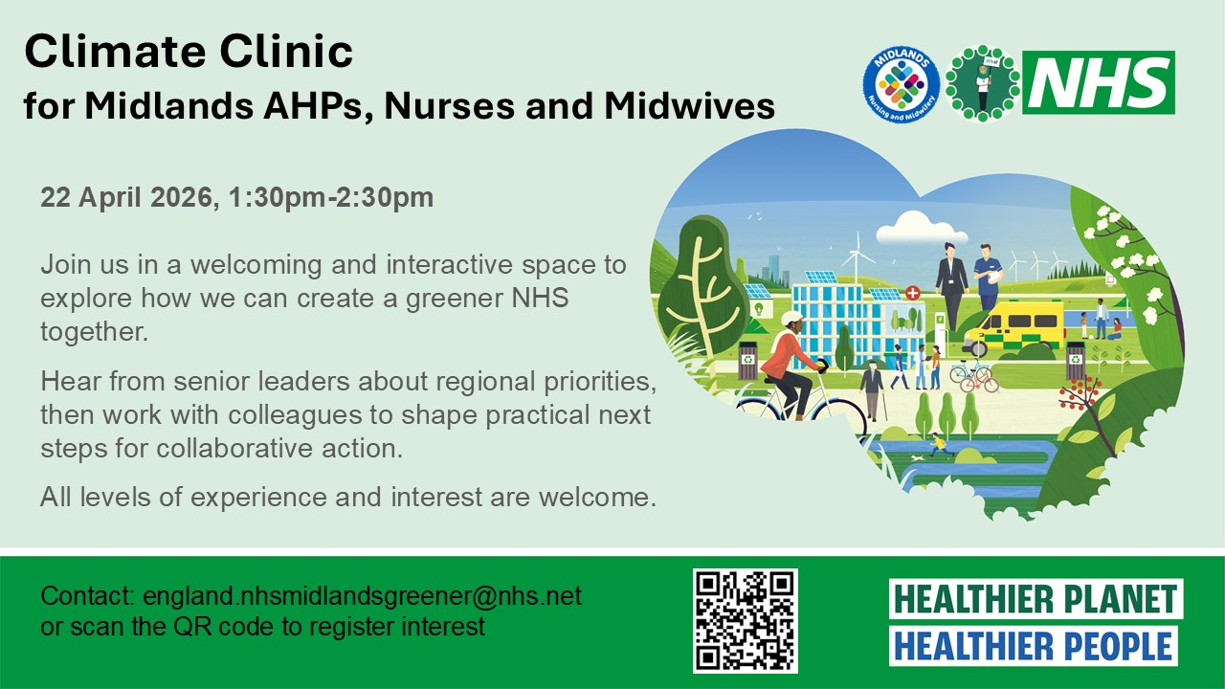
Register interest in the Climate Clinic here.

Methodology to progress clinical pathway decarbonisation from GIRFT
The GIRFT team has published the methodological framework it uses to support the programme’s work on rapid decarbonisation of clinical care pathways.

The study, published in the British Medical Journal Evidence Based Medicine, is entitled Environmental Lessons Learned and Applied (ELLA): a new framework for identifying, prioritising and implementing decarbonisation interventions in clinical care pathways and describes GIRFT’s ELLA framework, which allows decarbonisation opportunities within care pathways to be quickly and easily identified and prioritised.
The ELLA methodology has already been applied to bladder cancer care and total hip replacement pathways, and further guides on total knee replacement, urological stones and skin lesion pathways are being developed.

The Impact of AI on the Environment
Take a look at this slide pack on FutureNHS, which provides an overview of the environmental impacts of AI.

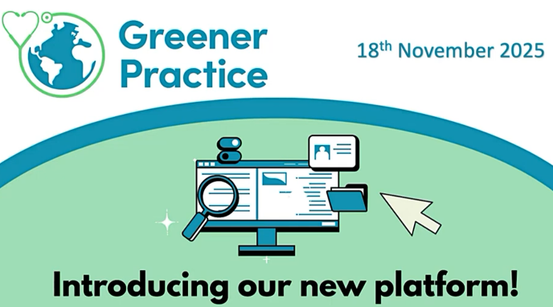
Primary care

New Greener Practice Platform
Greener Practice have launched this YouTube video, showing how their new platform works to make sustainable primary care easier.

Workforce & leadership


NHS Excellence Awards
The new NHS Excellence Awards are open, recognising outstanding work taking place across health and care. Find out more and enter before 5pm 6th March.
There are ten award categories that reflect the priorities of the 10-Year Health Plan, including a sustainable healthcare award. Shortlisted regional champions will be announced in mid-April 2026 and national winners will be celebrated at an awards ceremony at NHS ConfedExpo on 10th June 2026.


Greener NHS Carbon Literacy E-Learning Pathway
Additional dates have now been added to this pathway, up to May 2026.
The Greener NHS Carbon Literacy E-Learning Pathway offers a deep dive into the vital link between climate change and healthcare. This free course is open to all NHS colleagues with a valid NHS email address.



Greener AHP Week 20-24 April
Greener AHP week this year will be taking place on Monday 20 April to Friday 24 April. Take a look at the events that will be happening across the week.

Travel & transport
University Hospitals of Leicester are Excellent Modeshift STARS!
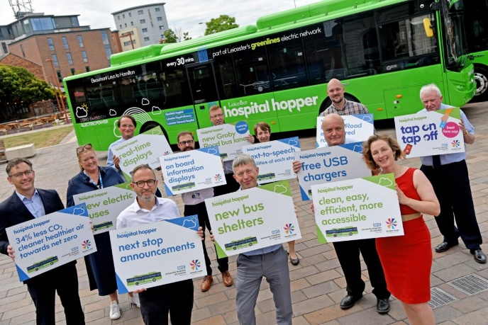
The University Hospitals of Leicester NHS Trust (UHL) has become the first NHS site to earn ‘Excellent’ Modeshift STARS Accreditation status. The Leicester Royal Infirmary (LRI) earned this award, reflecting the trust’s long-term commitment to creating a culture where active and sustainable travel is encouraged, supported, and celebrated. The LRI team has introduced a wide range of initiatives to make active and sustainable travel a realistic option for everyone including an electric bus linking hospital sites and nearby communities and cycle offers for staff.
Find out more.

Green space
Help plant 6,000 more trees
NHS Forest have launched a CrowdFunder to help make room for nature at healthcare sites.
Research from Brighton & Sussex Medical School and Brighton & Sussex Community NHS Foundation Trust shows that a view of nature significantly predicts inpatient length of stay. The CrowdFunder aims to raise funds to plant this coming season, to improve recovery times for patients, staff wellbeing, and positive experiences during treatment and stays, as well as managing flood risks, keeping buildings cool in summer and supporting wildlife.

Events
All events are now listed on our Midlands Greener NHS FutureNHS workspace calendar. Take a look at the GIRFT greener pathway webinar on hip replacement, taking place on 11th March, and the IPC Route to Net Zero Conference on 13th March.

Previous Midlands Newsletters
- Jan 2026
- Dec 2025
- Nov 2025
- Oct 2025
- Sept 2025
- August 2025

Get involved
We're keen to identify, share, and celebrate some of the best stories of greener health and care from across the NHS. If you have seen, or are involved in, an exciting programme or project that is helping the NHS to reach its net zero target, and think others could benefit from finding out more, please get in touch at england.nhsmidlandsgreener@nhs.net.

FutureNHS
We have updated our FutureNHS workspace, which now houses all the information and signposting that you should need. Let us know if you think anything is missing.

THANK YOU FOR YOUR ONGOING SUPPORT!

