Pharmacy First reports via Pharmoutcomes
Reports: Search for pharmacy first: Select Pharmacy First – Minor Illness/Clinical Pathway referral

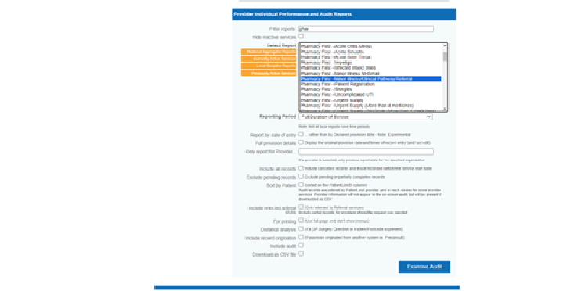

Then either select ‘Full duration of service’.

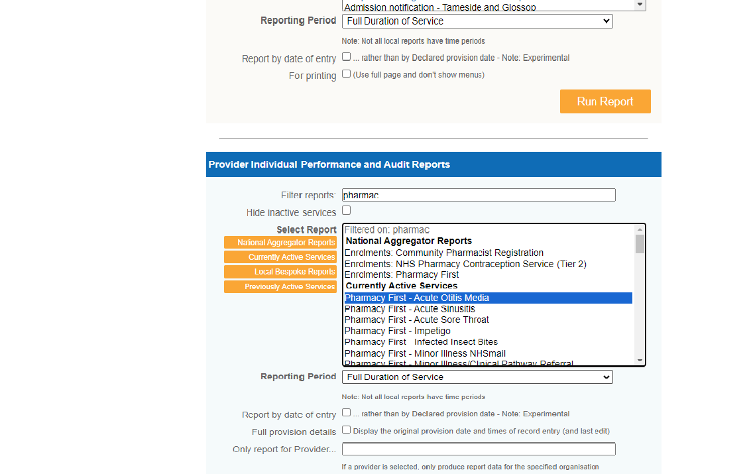

Or ‘Between specific dates’ and add a start and end date.
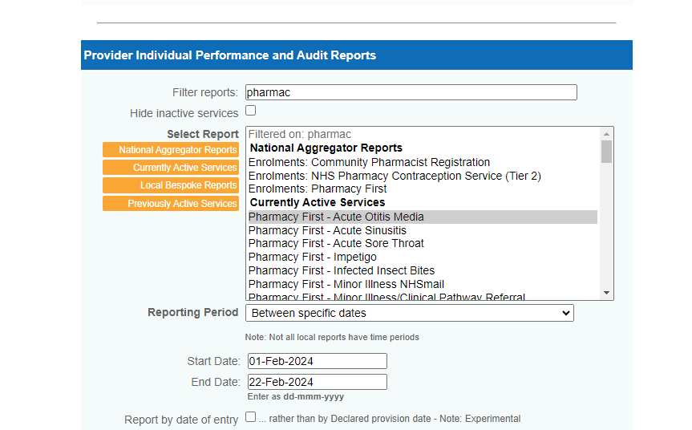

Then examine audit.
This will give you all of the data for the referrals made through Pharmoutcomes to the pharmacy. On page 6 of the data it shows how many have gone to Clinical pathway.

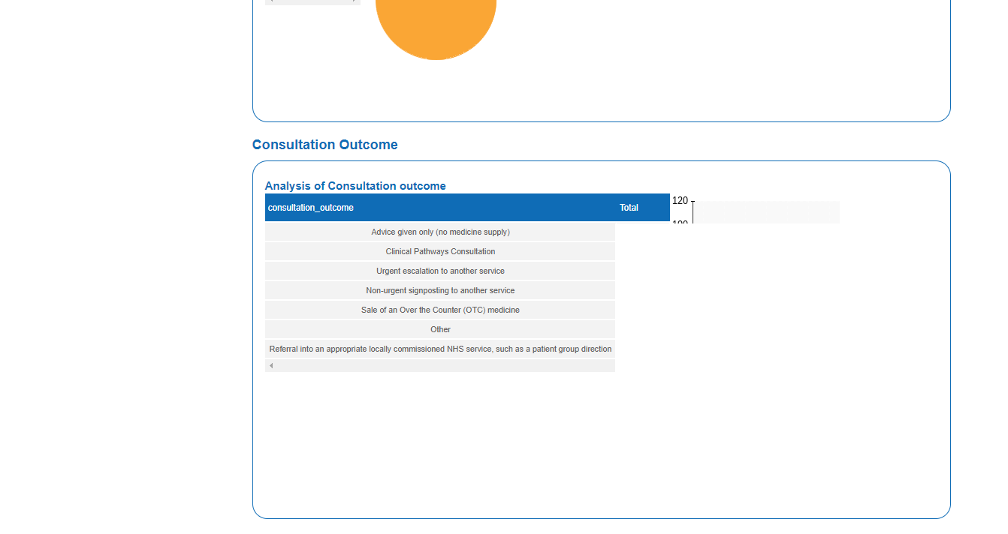
You can run a similar report for all ‘self-referrals/email referrals’.
As above but select patient registration:

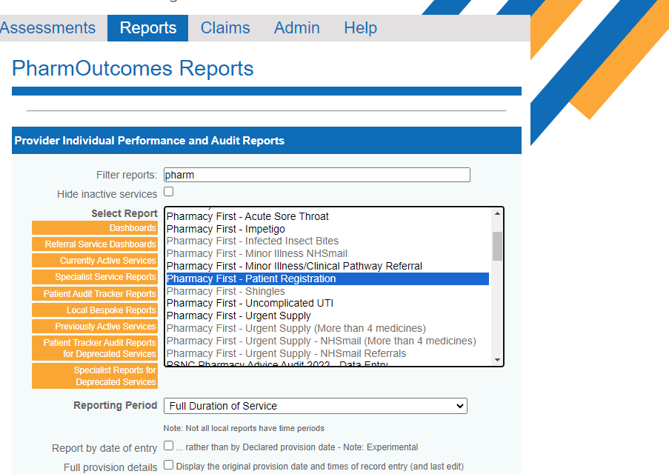
Examine audit again. This will show the data for all ‘walk ins’ and email referrals from surgeries. The two reports together give you the total number of customer interactions

