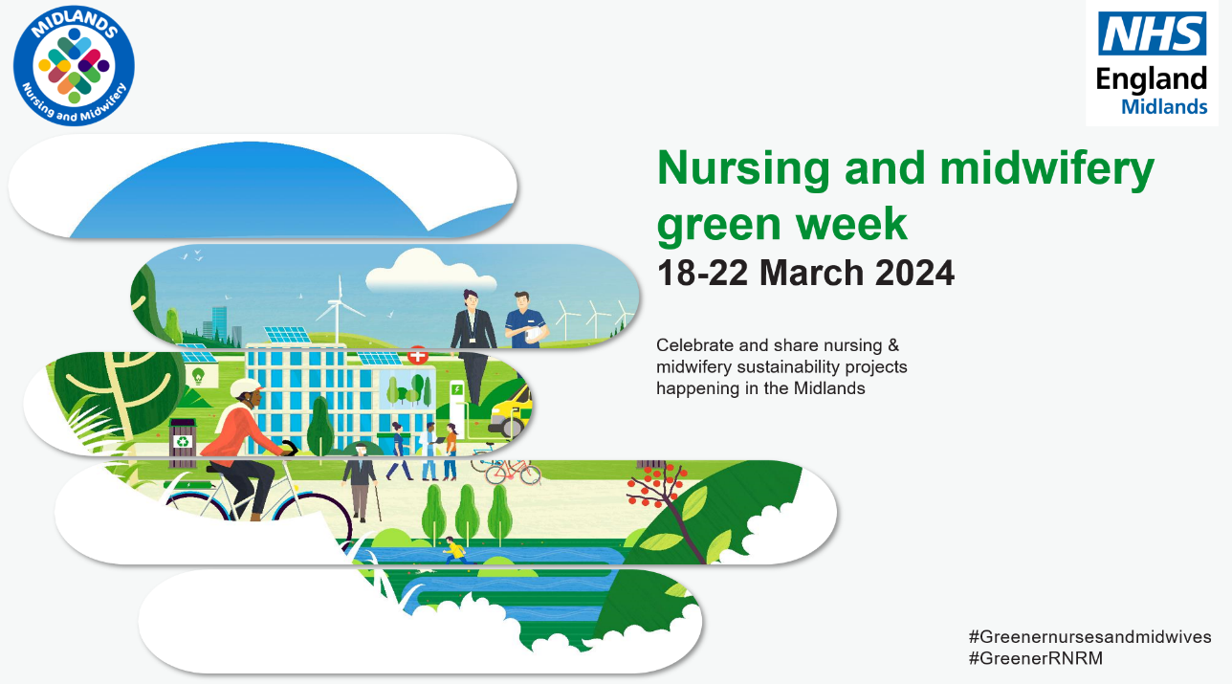
MIDLANDS - Greener Nursing and Midwifery Week 18th March 2024- 22nd March 2024 - Regional Plan
Key Objective- To amplify the contribution of Nursing and Midwifery in delivering NHS Net Zero Carbon Ambition, raise awareness, generating interest and mobilise nursing and midwifery expertise in planetary health. Delivering a ‘Net Zero’ National Health Service
Engagement opportunities throughout the week | - Calls for Action #Nursing & Midwifery Greener week. Tweet/ reshare training links  - Showcase competition, submit a poster, powerpoint or case study entries to england.midsroc2@nhs.net by 8th March  - All non-uniform nurses and midwives to wear green - “something old, something green, something borrowed something clean”?  - Teams backgrounds on  - Encourage photos/news/case studies  - Agenda item on all regular meetings to raise awareness  - Encourage and give permission for teams to hold walking teams and f2f meetings outside/in a green space  - Promote and share and lunch and learn sessions being delivered by the Greener Midlands Team during the week  - Light Buildings up in Green  - Air pollution –“round our way” Share link to the website where you can type in your own address or hospital postcode. Addresspollution.org then pledge something to reduce air pollution. addresspollution.org  - Invite people to share/ capture pledges within their organisation at each webinar, Lunch & learn session and share with regional/ national Greener futures site  - Comms package to go out the following week to capture photos, meeting chat comments / pledges/ doodle board
Webinars
Monday 18th | 12:00-13:00 – Lunch & learn: Gloves and Aprons Off Campaign  Kirsty Morgan, Assistant Director of Infection, Prevention and Control and Holly Slyne, Associate Director for Infection Prevention & Control, Northampton General Hospital NHS Trust  Teams joining link: Lunch and Learn Gloves and Aprons Off  Gloves off, RCN video link:  https://youtu.be/y9igNr-rtJs
Tuesday 19th | 12:00-13:00 - Lunch and Learn: Respiratory Issues - Maximise Control: Minimise Carbon Footprint?  How to achieve good control of your asthma and COPD patients and reduce the carbon footprint- is it achievable?  Joanne Hamilton, Principal CYP Asthma Nurse Practitioner and West Midlands Primary Care Respiratory Lead, Black Country ICB  Teams joining link: Respiratory Issues  National webinar  17:00-18:00 - Deborah Sturdy: Sustainability In Adult Social Care- continence and containment products  Book via Greener Nurses and Midwives Week | NHS England Events
Wednesday 20th | 11:00 -11:30 - A Greener Conversation with Regional Chief Nurse and Sustainability Team  Nina Morgan and Dominic Raymont, Regional SRO for Sustainability and Director Improvement  - What are the opportunities for greener care in the NHS  - What Behaviour change comes with leadership and requires a cultural shift.  - What is stopping nursing today?  - How do we engage individuals and teams to make sustainable change?  - Mentimeter questions/ jam board of pledges  Teams joining link: A Greener Conversation with Regional Chief Nurse and Sustainability Team  12:00-13:00- Lunch and Learn – GreenED: A guide to turning the Emergency Department green  Helen Wilkins, Consultant, University of Coventry and Warwickshire NHS Trust  Teams joining link: Green ED
Thursday 21st | National/ Regional webinar  09:00-10:30 Ruth May, National Chief Nursing Officer and National Sustainability Team.  10:30-11:30 Student discussion panel  11:30-13:00 Regional showcase presentations  Book via Greener Nurses and Midwives Week | NHS England Events  12:00-13:00 Shared learning session: It’s not easy being green  Clare Nash, Head of Clinical Products Management, Black Country Alliance  Learning outcomes  - Understand the impact of clinical products on the planet  - Tips from case studies - moving from single use back to reusables  - What you can do as nurses and midwives to support getting to net zero  Teams joining link: It's not easy being green
Friday 22nd | 11:00 DoN call: Hybrid role - Rhea Conn – National Sustainability fellow  National webinar  12:00 -13:00 - Sustainability in Adult Social Care – reducing the use of gloves and plastics.  Book via Greener Nurses and Midwives Week | NHS England Events  13:30 -14:15 - Piloting the hybrid sustainability nurse role at Sandwell and West Birmingham Hospitals – nurses, midwives and healthcare associates are key to driving adoption and spread?  Rhea Conn, Chief Sustainability Officer’s Clinical Fellow  Teams joining link: Piloting the sustainability nurse role at SWBH
Resources and links for sharing | Elearning for health launch  Environmentally Sustainable Healthcare - elearning for healthcare (e-lfh.org.uk)  Building on the basics  Home - The Carbon Literacy Project  Leading small changes and building QI skillset  Sustainability in Quality Improvement | Centre for Sustainable Healthcare  Supporting N&M leaders to shift the culture and change behaviours  Leading Sustainability in Health and Social care | Professional services | Royal College of Nursing (rcn.org.uk)  RCN courses “Leading Sustainable health and social care”  Leading Sustainability in Health and Social care | Professional services | Royal College of Nursing (rcn.org.uk)  Carbon literacy training or SusQI from CSH for nurses and midwives.  Sustainability in Quality Improvement | Centre for Sustainable Healthcare

To note activities Greener Midlands team
- focus on air pollution, inhaler usage for respiratory nurses. raising awareness of the GINA guidance for asthma care, to improve the comparatively poor asthma care we have in the UK and, as a by-product, reduce carbon. highlighting the dangers of air pollution for pregnant women to midwives and encourage consideration of alternative care approaches to avoid exposure.
- Midlands Greener NHS team run lunch & learn sessions regularly and record them all. - share our FutureNHS space, which people can join, and the recordings hosted here: Lunch & learn sessions - Midlands Greener NHS - FutureNHS Collaboration Platform. Feel free to promote any as part of the webinars, seminars and training aspect of the week.
- surgical/OT nursing colleagues may be interested in our upcoming Regional Roadshow on Sustainable Surgery and Operating Theatres - Midlands Greener NHS Regional Roadshow: Green Surgery | NHS England Events.

